Tutorial 7
Q1
Describe memory-mapped I/O and direct I/O. Give the main advantages and main disadvantages of each.

Q2
In a PIC18 system, the addresses of the status register & data register of an input device are E00H & E01H, in data memory space, respectively. When bit 0 of the status register is 1, the data to be input by CPU is ready. Both status & data registers are 8-bits long. Write the instruction sequences using to check the status register continuously and input the data when data is ready.

Q3
Suppose that there is a 12-bit ADC with and . Find the corresponding voltage values for the A/D conversion results of 80, 180, 480, 640, 960, 1600, 2048, 3200 and 4000.

Q4

Determine the output voltage of the following circuit.

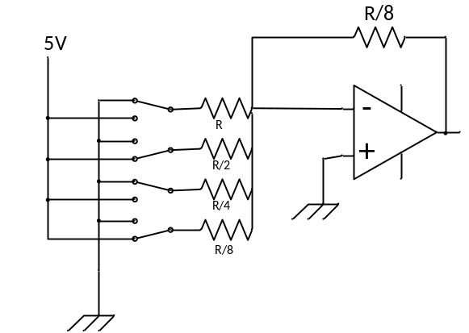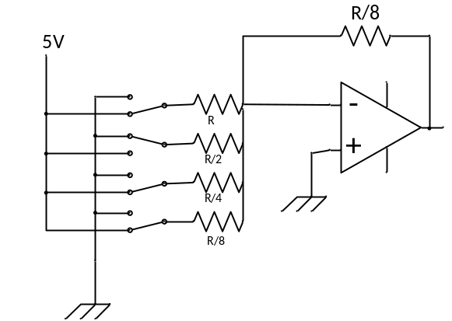
- Q5 For the following ADC circuit, let Vref = 1 V.
Determine the output of the comparators and the binary output if

(a) Vin=0 (b) Vin=0.23 (c) Vin=0.51 (d) Vin = 0.8

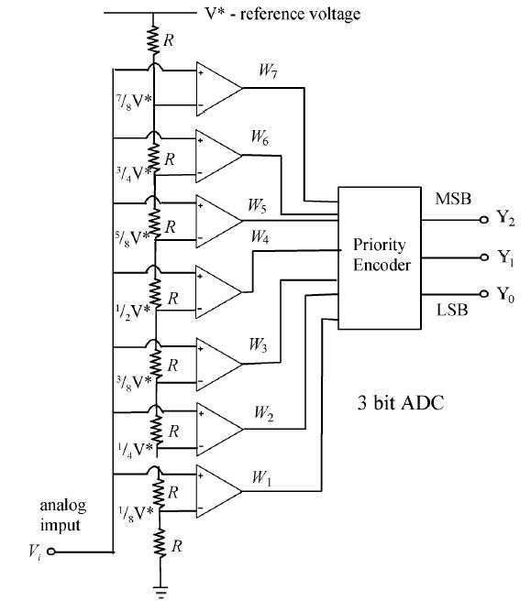
(a) 000 0000 binary output=000
(b) 000 0001 binary output=001
(c) 000 1111 binary output=100
(d) 011 1111 binary output=110

Q6 Assume f_{OSC} = 10MHz, Calculate the conversion time per bit (T_{AD} ) for all possible ADCS2:ADCS0.

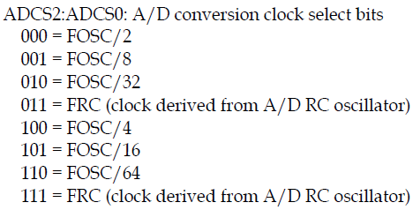

000 = fosc/2 => 200 ns
100 = fosc/4 => 400ns
001 = fosc/8 => 800 ns
101 = fosc/16 => 1.6 μs
010 = fosc/32 => 3.2 μs
110 = fosc/32 => 6.4 μs

Q7 The PIC18F4520 has an on-chip ADC. ( Ture or False)

Q8 The unused analog pins of the PIC18F4520 can be used for digital IO pins. . ( Ture or False)

Q9 The ADC module of the PIC18F4520 can convert only one channel at a time. . ( Ture or False)

Q10 With Vref+=2.56V and Vref-=0V, find the Vin for the following outputs:

(a) 11 1111 1111 (b) 10 0000 0001 (c) 11 0011 0000

Q11 Find the value for ADCON1 and ADCON2 if we want Tad=fosc/4, Tacq=8Tad, 4 channels of analog inputs with external source for Vref+ and Vref- and left-justified output.

Q12
Assume f_{OSC} = 4MHz, write a few instructions to configure PIC18F4520 ADC with the following requirements:
  - ADC converts the analog signal fed into Channel AN3.
  - Set AN0 to AN3 as analog inputs, other A/D port pins for digital I/O.
  - ADC result is left justified.
  - Select V_{DD} and V_{SS} as reference voltages.
  - Select the minimum possible T_{AD}
  - Select the minimum possible T_{ACQ}
  - Turn on ADC module
Do not start ADC yet
T_{AD} must be at least 0.7us and T_{ACQ} must be at least 1.4μs.

Q12
Assume that the AN0 and AN1 pins of a PIC18 running with a 4 MHz crystal oscillator are connected to a potentiometers. The voltage range of the potentiometer is from 0V to 5V. The reference external sources Vref+=5V and Vref-=0 are used.

Write a program to measure the voltages applied to the AN0 and AN1 pins, convert them, and retrieved the conversion result and place it in RAM location 0-3.
Let the minimum value of T_{AD} = 1.6 μs and the minimum value of T_{ACQ} = 10 μs

Q13
(a) Derive an expression for V_{out.}
(b) Choose appropriate resistor values and the adjusting voltage so that the circuit shown in the last
page can shift the voltage from the range of –5V ~ 5V to the range of 0V ~ 3.3V.

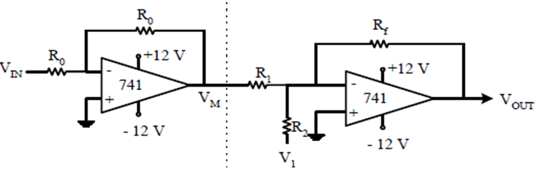

Q14
Describe the double handshake between two devices.

